Mobile Lights

Concept and Pitch Document

Elevator Pitch

Mobile Lights is a puzzle game in which the player toggles lights on and off in an attempt to light the entire board. The lights differ in shape, which indicate how they will affect the lights around them. Thus, a square light toggles each other light within a 1 unit radius, while a + light toggles only the lights in the four cardinal directions. Players complete a board and move on to the next one when all the lights on a board are switched on.

Beginner levels will be based on simple toggled lights, introducing new shapes as the levels progress. More advanced levels will introduce new concepts such as trigger lights, bounded lights, broken lights, boards which have some lights on by default, and more. Each of these advanced concepts are explored later in this document.

Initial development of the game will take place in Unity for Android devices. iOS and PC compatibility may be pursued at a later time. The core goal of this project is three-fold. First, learn to develop for mobile devices, including implementation of metric tracking and ad services. Second, have a professional title that can be shown off and talked about with other developers. Third, maybe make some money. The first two goals are the most important, with the third being a potential side benefit, though not a revenue stream to be counted upon.

Images from the Prototype for reference:

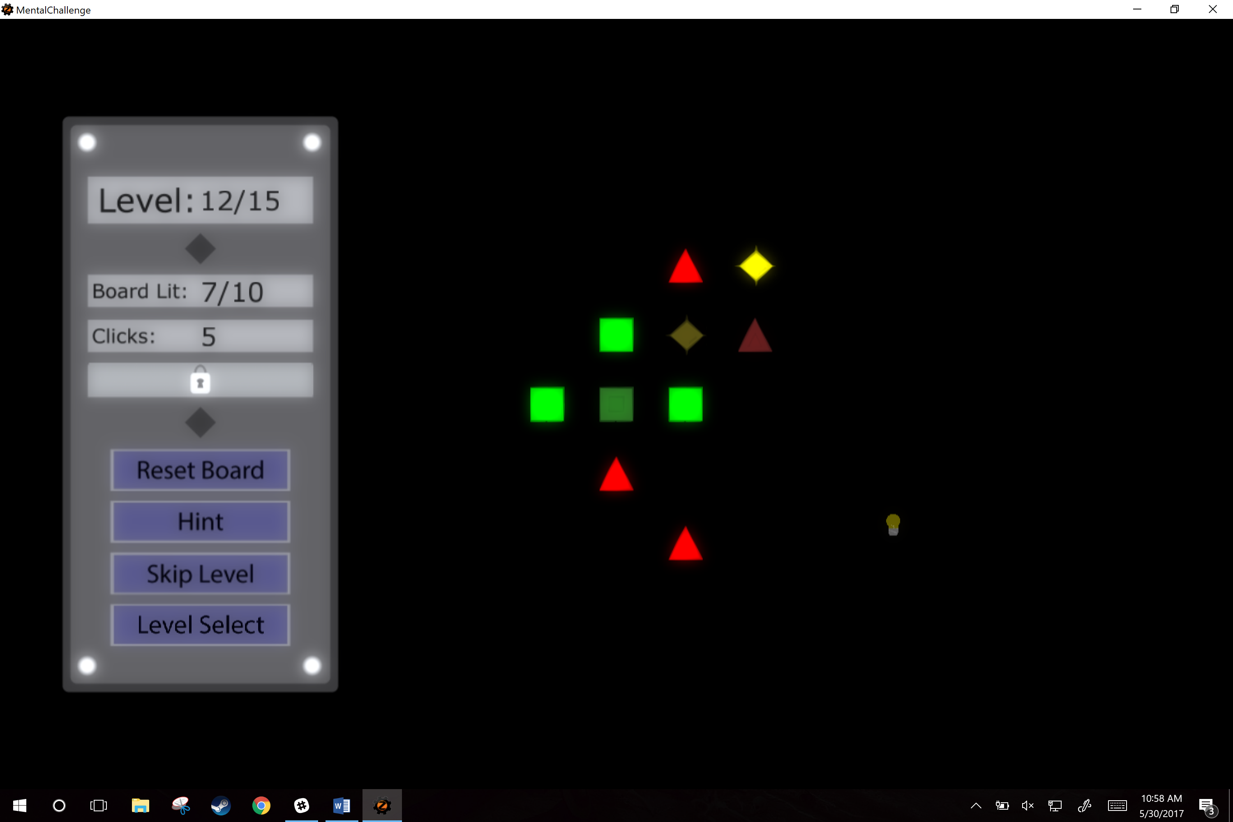 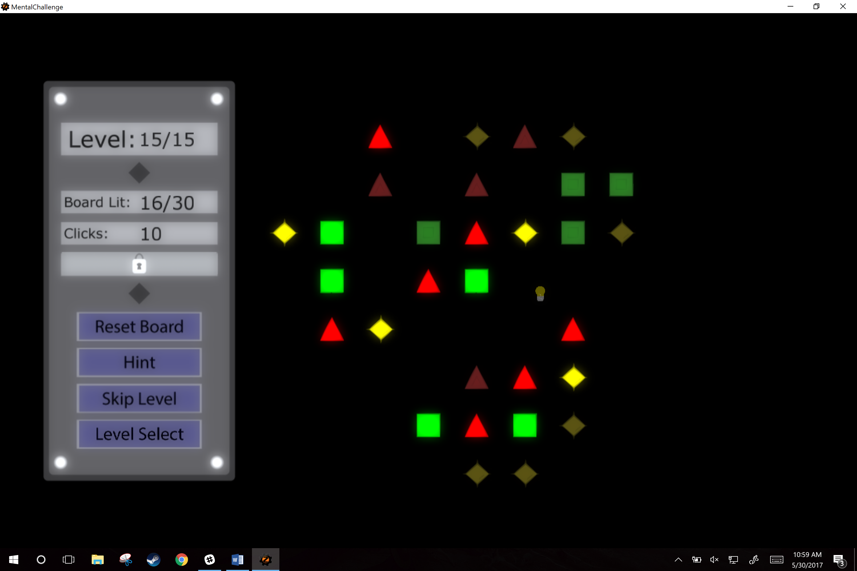

**Light Types:**

|  |  |  |  |  |
| --- | --- | --- | --- | --- |
| Square Light | Triangle Up Light | Triangle Down Light | Vertical Line Light | Horizontal Line Light |
| Connected Lights | Plus Light | X Light | Slash Light | Backslash Light |
| Generic Light (No interaction) |  |  |  |  |

The original prototype contained only Square, Triangle Up, and Plus lights. The full version will contain each of these new variants as well. Each of the shapes, other than Generic and Connected Node, follow the same logic as the original light, they toggle the lights around them based on their shape.

The Square, Plus, and X lights affect other lights 1 unit away. The Triangle Up, Triangle Down, Vertical Line, Horizontal Line, Slash, and Backslash lights affect other lights 1 and 2 units away.

Generic lights cannot be trigger by player interaction, only the toggling from another light. Thus, in a level with a single Square Light surrounded by Generic Lights, only the Square light can be clicked on. Doing so, it will toggle all of the Generic Lights within 1 unit of it.

Connected Lights are similar to Generic Lights with one exception, they are connected to another light any distance away from them (depicted by a connecting line). Just like Generic Lights, they cannot be directly interacted with. Instead, they can be toggled by clicking on a light within range of it that would normally toggle it, or by toggling the light it is connected to, either through direct interaction or from being toggled by another light.